Web Development – Mr. Turner

Smiley Face - CSS

**Project Overview**

Using CSS, you will manipulate some very simple HTML code to look like a face that blushes when you hover over it with the mouse. ***You may not change the HTML in any way (except to add classes if needed)!***

**Project Design**

This is Willie.

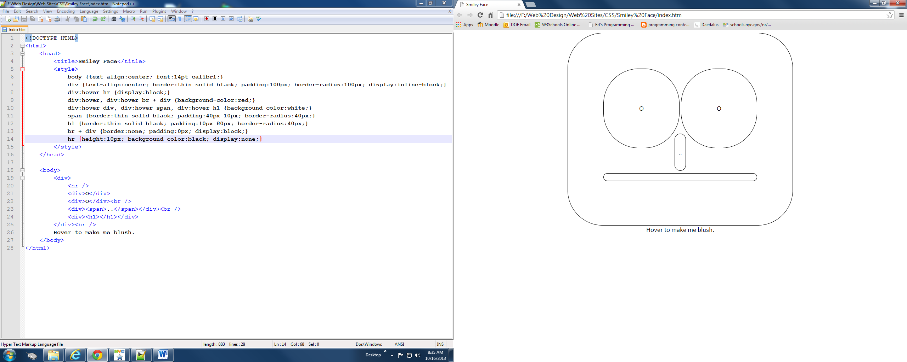

This is Willie when the mouse hovers over him (note the eyebrow).

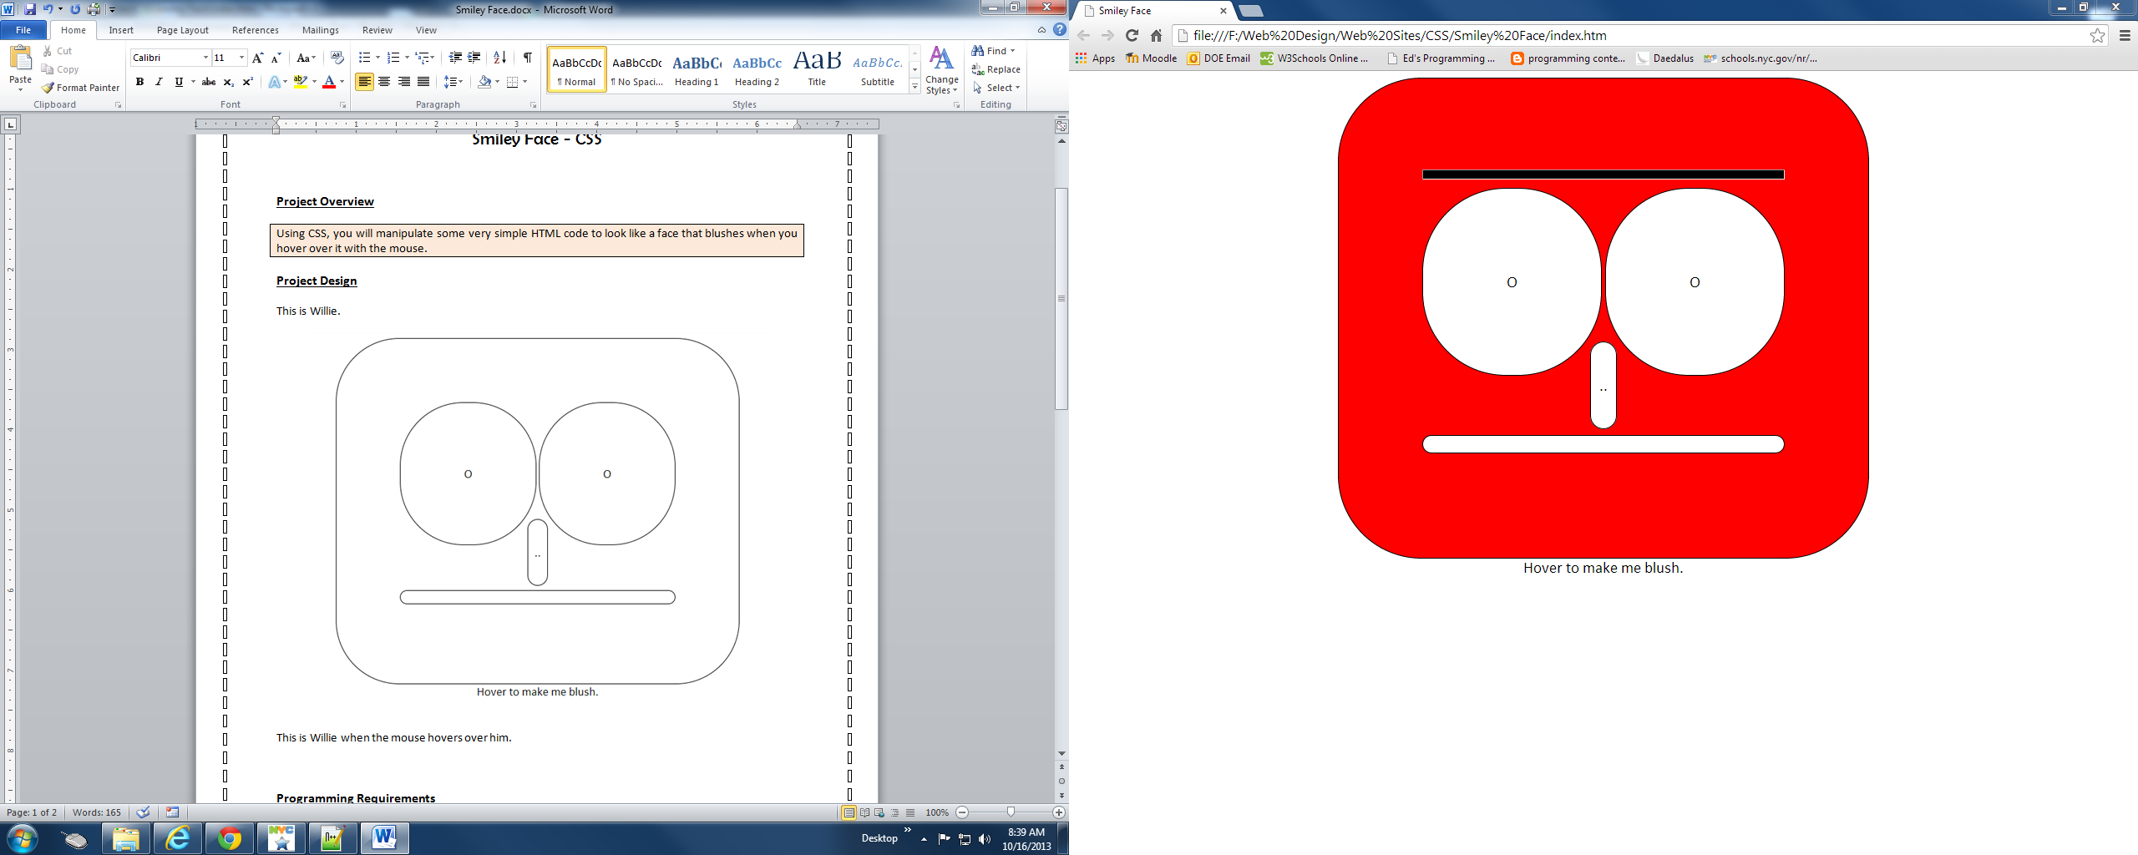

**Bonus**

***Program just one of these faces.***

Willie might look like this when the mouse hovers over him (if he’s surprised).

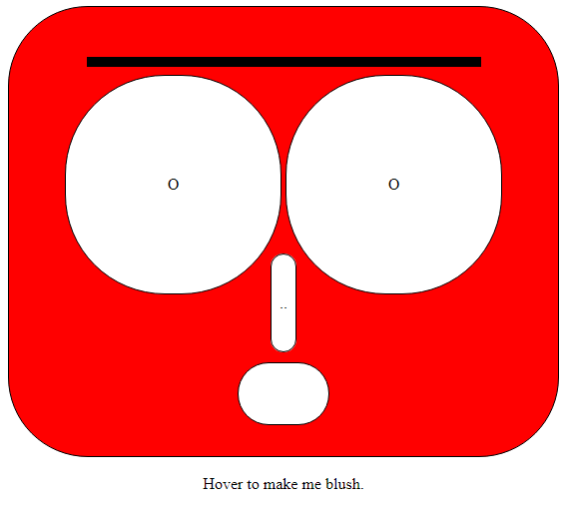

Or this (if he’s eye rolling).

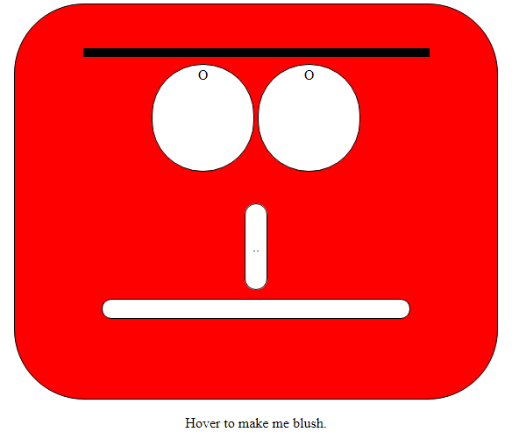

Or this (if he’s suspicious).

